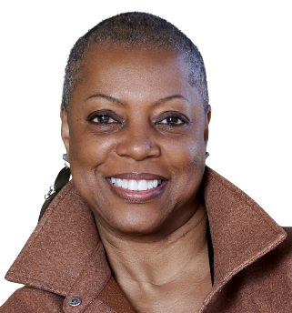
Angela C Ferguson

Artist Statement
I create art dolls that are more than just toys. They are statement pieces. They are expressions of my imagination, my emotions, and my stories. Each doll is handcrafted with care and diligence using a variety of materials such as clay, fabric, paint, and found objects. My soft sculptures are not meant to be realistic nor conventional, but rather whimsical and original. They reflect my personal style, my influences, and my inspirations. Some of my dolls are inspired by fairy tales, myths, and legends, while others are based on my own experiences, dreams, and fantasies. My dolls are not only decorative, but also interactive. They invite the viewer to touch, play, and explore. They have personalities, histories, and secrets. They are my companions, and friends, and my alter egos. Through my art dolls, I hope to share my vision of a magical and playful world, where anything is possible.
Angela is a self-taught, 67 yrs., old visual artist. Born and raised in Columbus, OH, she currently resides in Columbia, VA. She has a background in Fashion Merchandising, Executive Administration, and is a US Army Disabled Veteran. Angela is member and past president of African Americans for the Arts (AAFTA), a local non-profit organization of visual and performing artists in the metro Atlanta area.

Website: Acfergusonarts.com
Cell: 404-556-6100
Email: acfergusonarts@gmail.com

